Lab 2: Basic Data Structures
You may work with a partner
Exception: ZeroDivisionError for frequencies (empty text)
Special case: american/canadian? Text only contains stopwords?

In this lab, you will process some text data using lists, sets, and dictionaries. Write your program in main.py. The steps below describe tasks you must accomplish, but the coding is up to you. Try to decompose your program into functions to keep it organized.

Step 1: Read data from files
In the data folder of the starter code provided on D2L, you will find 2 “text” documents and 1 “stopwords” document.

The stopwords document contains words that appear frequently in English documents, but don’t add a lot of semantic meaning (words like “a”, “me”, “it”, etc.). Read this document and create a set of all the stop words.

Read the 2 text documents and split each into a list of individual words. Exclude all stopwords from these lists.

Step 2: Calculate term frequencies
Create a dictionary for each file, showing the number of occurrences of each word. Like this (this is just an example, the values may not be right):
{“may”: 2, “without”: 4, “science”: 1 ….}

Now convert these raw counts into term frequency scores. “Term frequency” is just the relative frequency of the word in the document. So the term frequency (tf) for the word w_{i} is:

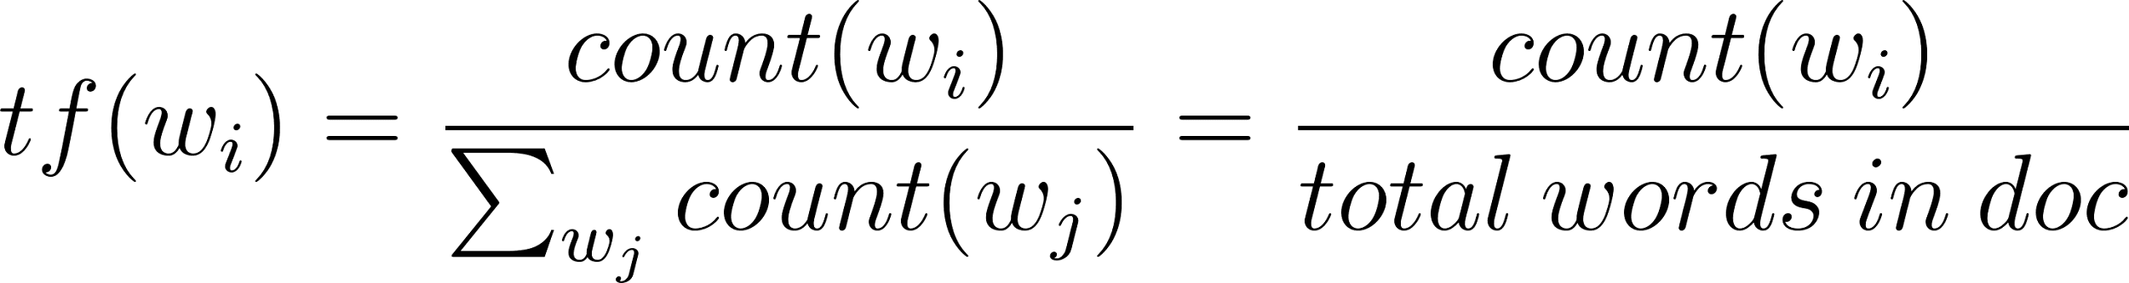

Term frequencies are sometimes used in text analytics, on the assumption that words with high frequency in a document are important for understanding what that document is about.

Step 3: Reduce to unique words
Reduce each dictionary to the words that are unique to that document. That is, remove any words that appear in both documents.

To do this, first compute (and print) the set of words that is common to both documents. Then remove those keys from each dict.

Present Your Lab Solution in Jupyter Notebook
After completing and testing your solution in your development environment, use a Jupyter Notebook to present your work and demonstrate that it satisfies the lab requirements. Use the notebook to review your solution and complete the lab pass-off with your instructor.
The notebook should clearly present your solution, testing process, and results. Ensure it has access to all required files and resources by keeping your solution files, supporting files, input data, and notebook in the same project folder.
Begin by preparing everything needed to run your solution:
- Import your code or required modules.
- Load required data or files.
- Define test inputs or configurations.
Present your solution step by step rather than showing only the final output. Demonstrate:
- How inputs are processed.
- How key functions or components work.
- Important intermediate results.
- How your solution satisfies the lab requirements.
Use a variety of test cases to verify your solution, including:
- Normal cases: Valid inputs with expected results.
- Special cases: Unusual but valid situations.
- Error cases: Invalid inputs or unexpected conditions (if applicable).
For each test case, show the input, expected behavior, and actual result. If your solution includes error handling, demonstrate how it detects and manages errors appropriately.

Submission:
Submit your solution to D2L in the designated submission folder as a single ZIP file (only one submission per group) containing:
- All source files (.py) and your Jupyter Notebook (.ipynb).
- Screenshot(s) of your complete GitHub commit history (for you and your partner, if applicable), along with confirmation that your work has been pushed to GitHub.
You must also present your solution in Jupyter Notebook and complete the lab pass-off with your instructor, following the Present Your Lab Solution in Jupyter Notebook guidelines.
During the Thursday lab session, students will complete and demonstrate their laboratory work in person to the instructor for assessment.

